# Certolizumab Pegol Efficacy in Patients with Non-Radiographic Axial Spondyloarthritis Stratified by Baseline MRI and C-Reactive Protein Status

Atul Deodhar,1 Lianne S. Gensler,2 Stephen Hall,3 Philip C. Robinson,4 Bengt Hoepken,5 Lars Bauer,5 Thomas Kumke,5 Walter P. Maksymowych6

*1Oregon Health & Science University, Portland, OR, USA; 2University of California San Francisco, San Francisco, CA, USA; 3Cabrini Medical Centre, Monash University and Emeritus Research, Melbourne, Victoria, Australia; 4University of Queensland School of Clinical Medicine, Brisbane, Queensland, Australia; 5UCB Pharma, Monheim am Rhein, Germany; 6University of Alberta, Edmonton, Canada*

**Background:** This post-hoc analysis from the phase 3 C-axSpAnd study aimed to evaluate whether the response to certolizumab pegol (CZP) in non-radiographic axial spondyloarthritis (nr-axSpA) is impacted by patients’ baseline MRI and C-reactive protein (CRP) status.

**Methods:** C-axSpAnd (NCT02552212) was a 3-year, phase 3, multicenter study including a completed 52‑week double-blind, placebo-controlled period.1 Patients were adults with a diagnosis of axSpA, meeting Assessment of SpondyloArthritis international Society (ASAS), but not modified New York, classification criteria, active disease (Bath Ankylosing Spondylitis Disease Activity Index [BASDAI] ≥4, spinal pain ≥4), objective signs of inflammation (CRP ≥10 mg/L [CRP+] and/or evidence of sacroiliitis on MRI [MRI+]), who had failed ≥2 non-steroidal anti-inflammatory drugs. Patients were randomized 1:1 to placebo or CZP (400 mg at Weeks 0, 2, and 4, then 200 mg every 2 weeks), which they received in addition to non-biologic background medication for 52 weeks. Adjustments to background medication or switching to open-label CZP (or other biologics) at any point was permitted. We report Ankylosing Spondylitis Disease Activity Score – major improvement (ASDAS-MI) and ASAS 40% response (ASAS40) for CZP-randomized patients according to prespecified subgroups based on MRI/CRP status (MRI+/CRP+, MRI−/CRP+, MRI+/CRP−). Comparisons between MRI/CRP subgroups were descriptive only; Week 12 (ASAS40) and Week 52 (ASDAS-MI) comparisons between CZP and placebo were pre-specified. Missing values, or values collected after switching to open-label treatment, were imputed using non-responder imputation.

**Results:** At baseline, a total of 317 patients were randomized, 159 to CZP (45 MRI+/CRP+, 40 MRI−/CRP+, and 74 MRI+/CRP−) and 158 to placebo (42 MRI+/CRP+, 40 MRI−/CRP+, and 76 MRI+/CRP−). At Week 52, ASDAS-MI was achieved in 75 (47.2%) and 11 (7.0%) CZP- and placebo-treated patients, respectively, and ASAS40 in 90 (56.6%) and 25 (15.8%), respectively. When stratified by MRI/CRP status, response rates in all three subgroups for CZP-treated patients were also higher compared to placebo for both ASDAS-MI and ASAS40 at Week 12 and Week 52 (**Figure 1**). For ASDAS-MI, there was a greater difference in response rates between subgroups compared with ASAS40, with numerically higher response rates in the MRI+/CRP+ and MRI−/CRP+ subgroups vs the MRI+/CRP− subgroup (**Figure 1a**). Since the ASDAS value is largely dependent on the CRP value, this was to be expected. For ASAS40, the main secondary outcome, a numerically higher response rate was also observed for the MRI+/CRP+ group, while response rates were comparable for the other groups (**Figure 1b**).

**Conclusion:** Clinically relevant responses were observed in nr-axSpA patients with either MRI and/or CRP positivity, with the highest response seen in the MRI+/CRP+ subgroup.

**Reference:** 1. Deodhar A. Arthritis Rheumatol 2019;71:1101–11. **Funding:** UCB Pharma.

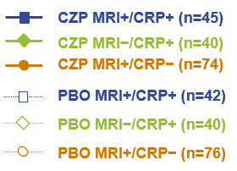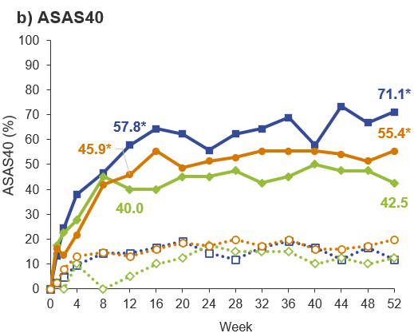**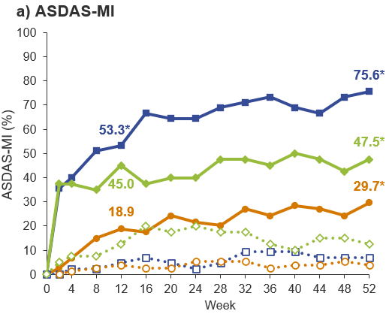Figure 1.** ADSAS-MI and ASAS 40 response in patients stratified by baseline MRI/CRP status

Missing values, or values collected after switching to open-label treatment, were imputed using non-responder imputation. *p<0.001 for CZP vs PBO. ASAS40: Assessment of SpondyloArthritis international Society 40% response; ASDAS-MI: Ankylosing Spondylitis Disease Activity Score – Major Improvement; CRP: C-reactive protein; CZP: certolizumab pegol; PBO: placebo.